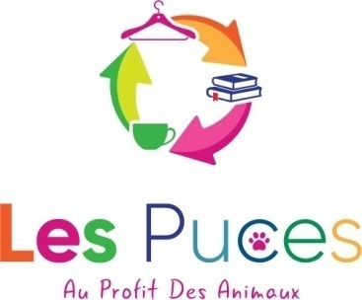
LES PUCES ADOPTION APPLICATION FORM

Full name:
Address:

Telephone:
Mobile:
Email:
Details of the animal you’re interested in adopting:

Details of your home: (house, flat, floor, secured or unsecured balcony, enclosed or unenclosed garden or area)

How many animals do you already have in your home?

Type of animal, how old are they?

Are they neutered? YES/NO

If you have cats, are they vaccinated against:(please specify negative or positive)?
Coryza/Typhus:
Leukaemia:
FIV/FELV:

What provisions do you have in place in your absence e.g. should you go on holiday?

Are you available to adoptan animal now?YES/NO

If not, when?

Any other information you think we’d find useful (family composition, experience, motivation etc.)

Signed:
Date:

Please email your application form to maldwyn_davies@hotmail.com or hand it in at our shop. We’ll take a look at your details and get back to you asap. If your application is accepted we’ll need to arrange a visit to your house or a video call.

Thank you,

Association No: W292003879
LES PUCES, 8 Place de la Mairie, 29246, Poullaouen
Alexandra Maldwyn-Davies - 06.14.51.47.39

