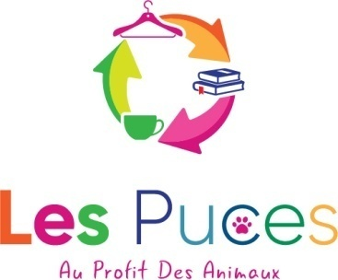
LES PUCES FOSTER APPLICATION FORM
Association No: W292003879
8 Place de la Mairie, 29246, Poullaouen
Alexandra Maldwyn-Davies - 06.14.51.47.39

Full name:
Address:

Telephone:
Mobile:
Email:

Details of your home: (house, flat, floor, secured or unsecured balcony, enclosed or unenclosed garden or area)

How many animals do you already have in your home?
Type of animal, how old are they?

Are they neutered? YES/NO

If you have cats, are they vaccinated against:
Coryza/typhus?
Leukaemia?
FIV/FELV?
(please specify if they are negative or positive)

Could you isolate a cat or kitten for quarantine? YES/NO

Where would the foster animals be kept?

Please explain your working status

Would the animals be alone during the day? YES/NO
How long would they be left alone?

Where will the animals be during your holidays?

Are you available to take in foster animals now? YES/NO
If no, when?

How many cats or kittens could you foster?

Do you have a regular vet, if so which one?

Any other information you think we’d find useful (family composition, experience, motivation etc)

Signed:
Date:

Please email your application form to maldwyn_davies@hotmail.com or hand it in at the shop. We’ll take a look at your details and get back to you asap. If your application is accepted we’ll need to arrange a visit to your house or arrange a video call.

Thank you

